# CS 340 README – Project Two

## About the Project/Project Title

Grazioso Salvare is a custom built interactive design that allows the client to search for dog candidates that can be a good fit for their rescue-animal training program. The dashboard connects directly to a MongoDB database that stores records from five animal shelters from Austin, TX; it lets users filter based on breed, age and sex in order to match the candidates to water, mountain or disaster rescue. The data can be visualized using an interactive table, geolocation map and dynamic charts.

## Motivation

The purpose of the project is to efficiently help Grazioso Salvare in the search of candidates that have a higher chance of succeeding at the training. The dashboard optimizes the selection process by integrating data from multiple animal shelters into a single platform.

## Getting Started

To get a local copy up and running, follow these simple example steps:

1. Ensure Python 3.8 or newer is installed.
2. Ensure Jupyter Notebook is installed.
3. Download project files (animal_shelter.py, ProjectTwoDashboard.ipynb and Grazioso Salvare Logo).
4. Launch Jupyter Notebook, open the ProjectTwoDashboard.ipynb file and run all cells.
5. Follow the link and use the dashboard to filter data, see dog’s location on the map and vie charts.

## Installation

Tools needed to use the software and how to install them.

* MongoDB
* Python 3.8 or newer
* Jupyter Notebook: Install via pip by entering the below command
  + Pip install notebook
* Python packages: Install via pip by entering the below command
  + pip install dash dash-leaflet jupyter-dash pandas numpy matplotlib plotly pymongo

## Usage

Once the dashboard is running, users can interact with its components to explore and filter animal shelter data. The top of the dashboard incorporates radio buttons that allow to visualize dogs based on rescue categories such as Water Rescue, Mountain and Wilderness Rescue and Disaster or Individual Tracking. Once a selection is made, the table below will only display animal data that is relevant to the search, these records can be filtered further using sorting, pagination and column filtering features. At the bottom left, a pie chart visually represents the distribution of the dog breeds in the filtered results. And lastly, at the bottom right, users have a geographic view of where the selected animal is located. The dashboard also has a reset option to return to the unfiltered data view. The screenshots below illustrate how the dashboard functions in practice:

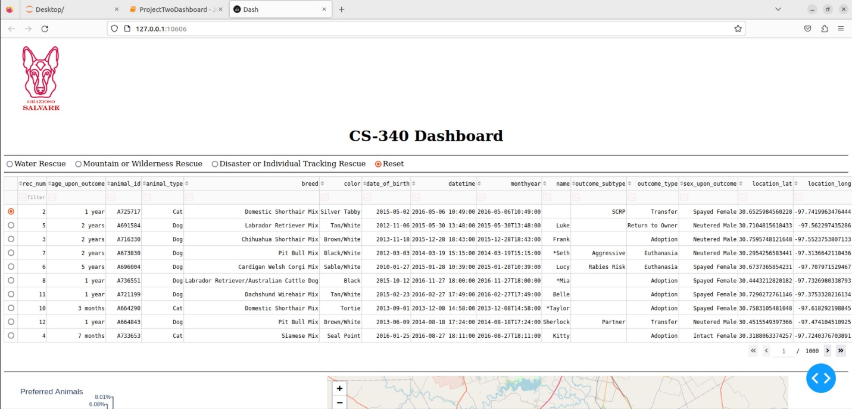

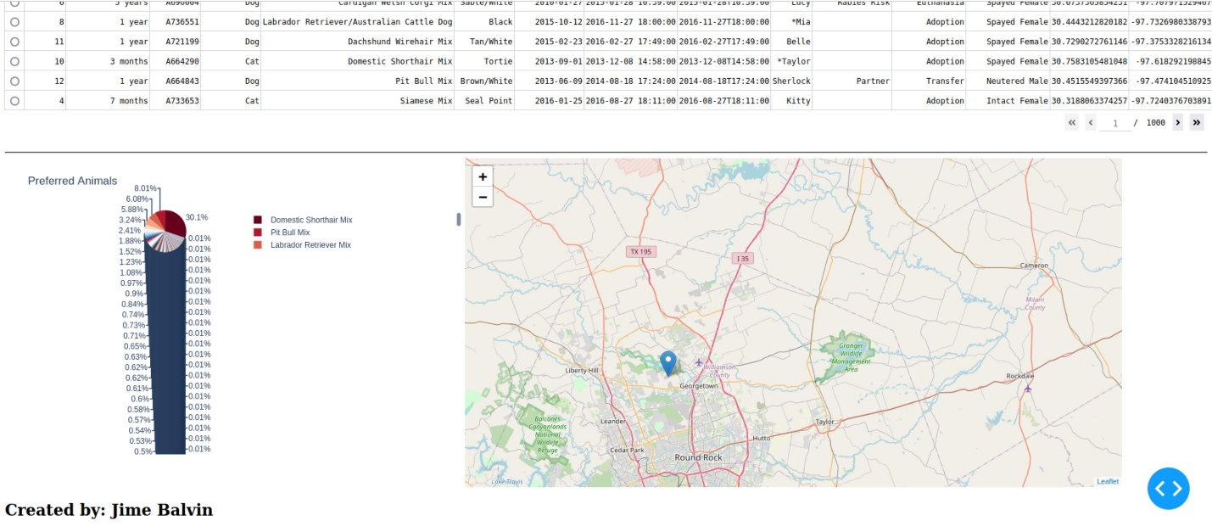

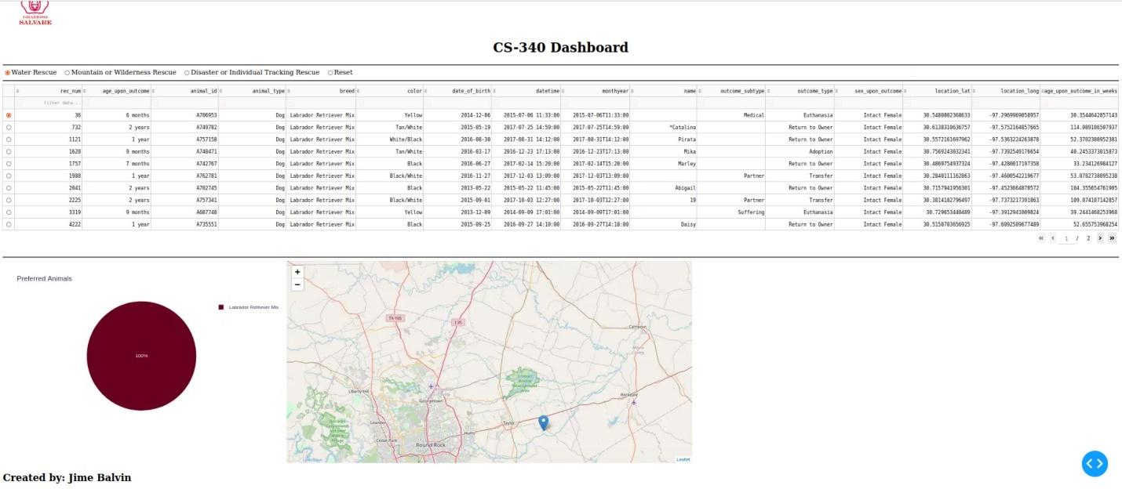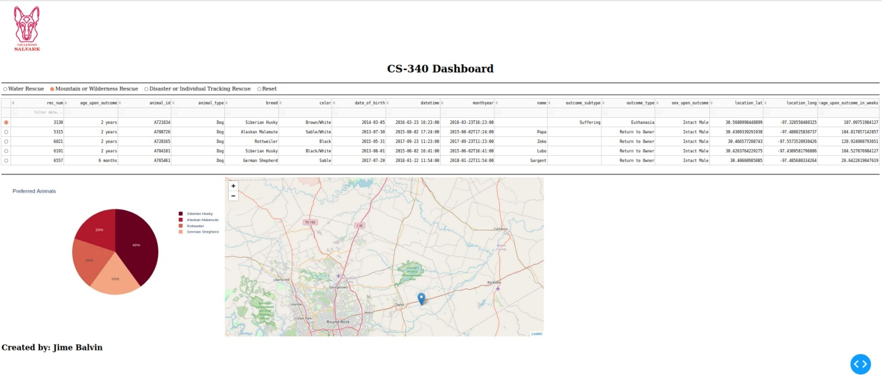

## Roadmap/Features

The dashboard currently has all core features requested by Grazioso Salvare (interactive filtering by rescue type, responsive data table, dynamic charts and geolocation). One future enhancement is to add the ability to export filtered results as CSV file, allowing the user to save, print and share dogs files offline among trainers and rescue teams.

What makes this project stand out is its capability to transform raw shelter data into an intuitive, decision making tool. It gives the client a centralized way to identify dog candidates in a real time.

## Contact

Jime Balvin